Kids menu

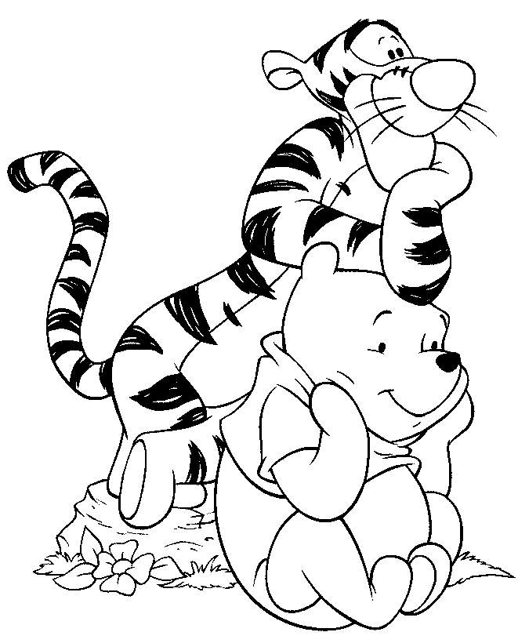
Main Courses

Battered Haddock Goujons
Battered Chicken Goujons
Pork sausage and gravy
Above served with chips peas or beans
Macaroni cheese with garlic bread
Make your own Pizza - choice of toppings:
Ham, Cheese, Tomato, Peppers, Mushrooms or Onion
Served with
Milk shake (strawberry, raspberry chocolate or banana)

Followed by
Sticky toffee pudding with ice cream
Chocolate brownie with ice cream
Penguin ice cream (don’t panic – I just look like a penguin – I don’t taste like one!!!!!)

Main course with milkshake £5.95
2 courses with milkshake £6.95

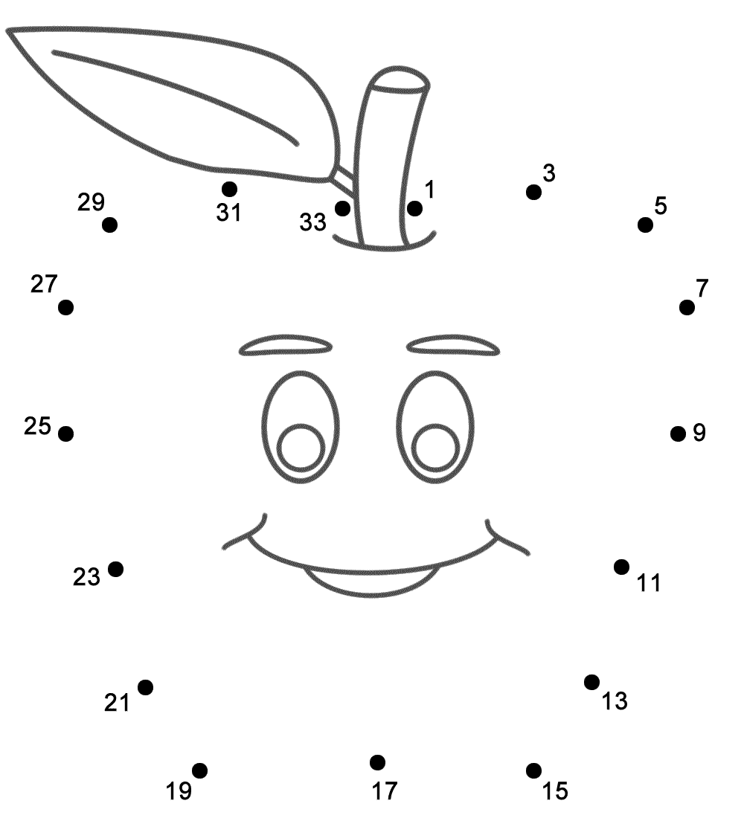
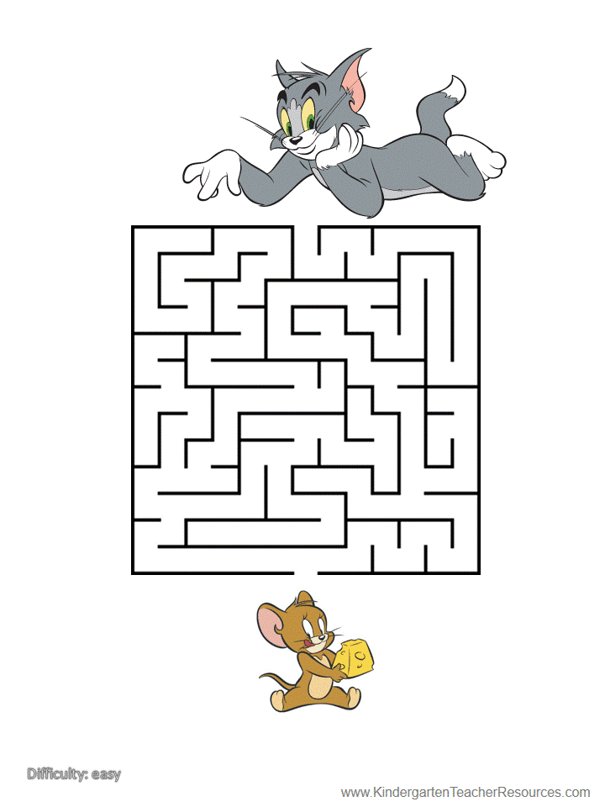
Tic Tac Toe

